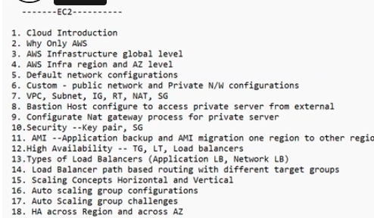

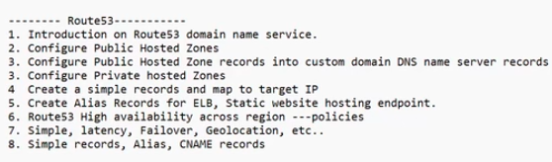

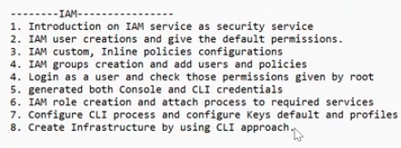

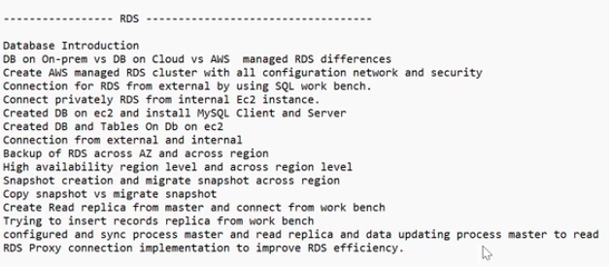

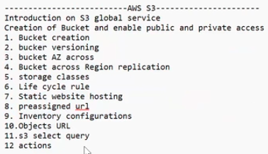

Pending topics

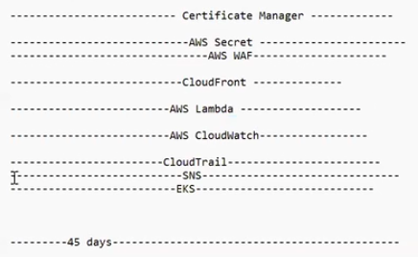

Volumes

We are created a instance with default volume with 8 gb, now we can increase the volume

Click on the instance

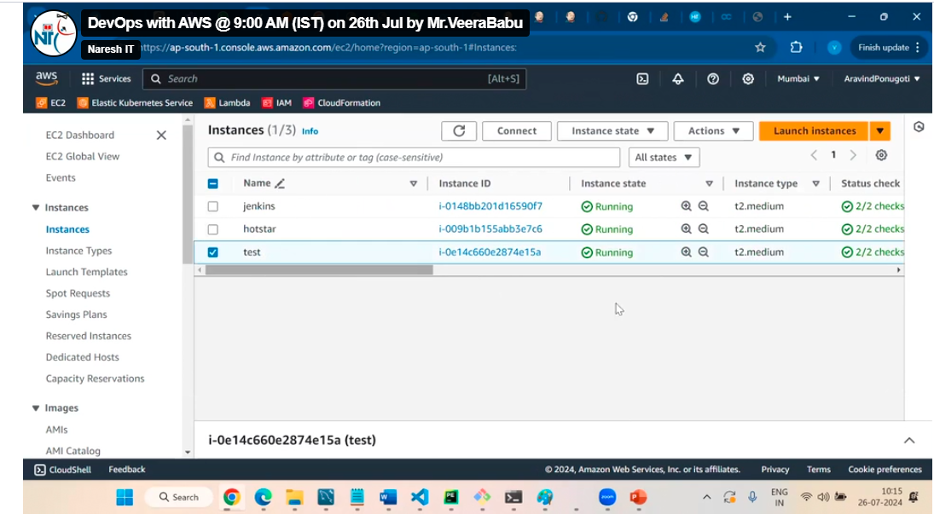

Click on the volume

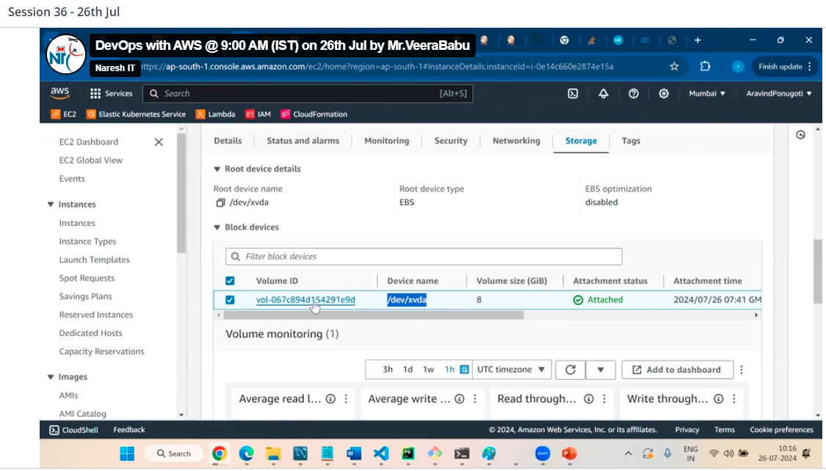

decreasing the volume not possible we can increase the volume

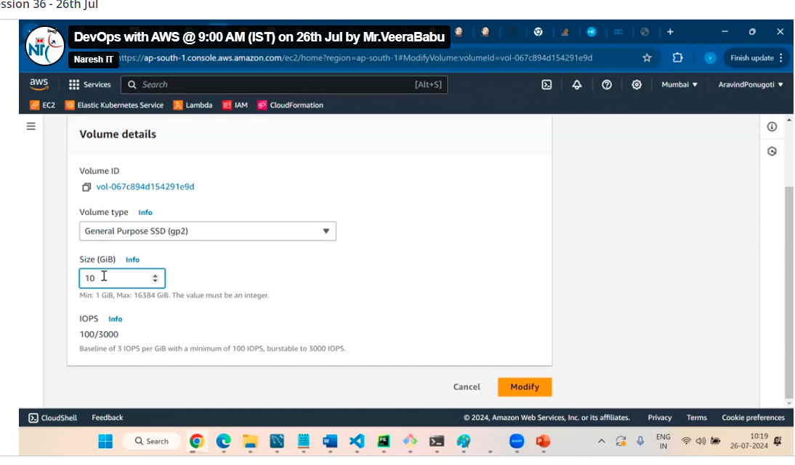

Then click on modify by this the volume is increase

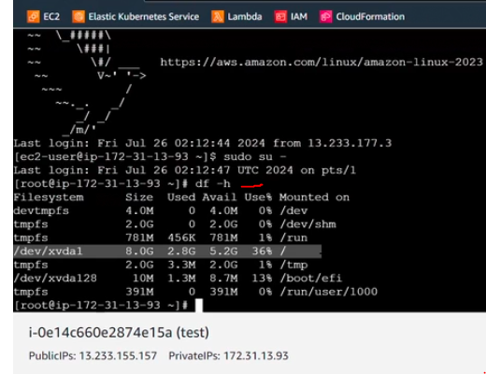

Inside server it is updating but in reality, it is not updating so for that we need to run one command

Wait some time and refresh it then we can see here

The volume is updated

Volumes are AZ specific

We can directly create additional volume, and we can attach to instance but make sure both are in one AZ